A monthly column pitched at Affluent Over-50 travelers

**The Column**

Simply Smart Travel is a popular and growing monthly travel column pitched at affluent over-50 travelers and armchair travelers. It was started in 2014 and is currently self-syndicated by the authors.

It is carried by newspapers and magazines in nine states (California, Nevada, Missouri, Ohio, Pennsylvania, Massachusetts, Maryland, Georgia and Florida), in small towns like Deerfield Beach, Gainesville, Sarasota and Youngstown, and in big cities such as Atlanta, Baltimore, Boston, Cleveland, Philadelphia, Reno and St. Louis.

It also runs online at [www.AfterFiftyLiving.com](http://www.afterfiftyliving.com/author/orenstein/) and in the digital editions on the web sites of many of the media that carry the column in print.

The column is an ideal vehicle to build circulation and reader interest among the over-50 demographic and to attract quality advertisers.

* The subject matter encompasses practical and interesting trip reports and destination-specific travel tips.
* Publications that run it frequently attract travel-related advertising around it.
* While its primary appeal is to the baby-boomer demographic, reader surveys show that it appeals to younger travelers too.
* The standard column length is 850-1,000 words and includes custom-prepared special-interest sidebars for publications that appeal to an ethnic or special-interest audience.
* Each column is accompanied by four to six all-rights-included high-resolution photographs, usually by the authors, and descriptive captions.
* The column is emailed in Word with accompanying jpg photos the 15th of each month.
* Back columns are available.

**The Authors**

Jeff and Ginny Orenstein live in Lakewood Ranch, a planned community a mere eight miles from the Gulf of Mexico and 20 minutes from downtown Sarasota and Bradenton, Florida.

They walk their talk. They’re both over 50 and love to travel to locations ranging from the exotic to the commonplace, although they’ve never found any place to be really commonplace once they explored it.

They’re also pretty good photographers who love to share their photos, travel tips and observations in print and in public appearances.

**Jeffrey “Jeff” Orenstein, Ph.D**.

Jeff was born and raised in Cleveland, Ohio. He has a B.A. from Ohio State University and an M.A. and Ph.D. (all in political science) from the University of Wisconsin-Madison and taught for 25 years at a large Midwestern University.

When he “retired” from teaching as a full professor, he became a newspaper editor and then a magazine publisher. He’s written several books and hundreds of articles on government, transportation and travel.

**Virginia “Ginny” Orenstein**

Ginny has a B.A. in accounting from Kent State University, is a C.P.A. (no longer practicing) and had a career as the Chief Financial Officer of large companies in steel, tires and building products distribution.

She has served on boards of numerous non-profit organizations in Florida and currently teaches financial literacy to young people

For more about Ginny: http://southernhospitalityblog.com/fashion-over-70/

**Endorsements**

“As an editor, I greatly appreciate Jeff’s timeliness, accuracy and relevance. His columns are always ahead of deadline and complete with photos and cutlines. He chooses travel topics that are relevant and appropriate for the time of year and audience. I especially appreciate the practical aspects of the columns that include advice for travelers that make their trips more comfortable and enjoyable. This is the kind of column our readers enjoy, save and share.”  
  - *Sondra Guffey, Editor, Suncoast Living Magazine*

"We have been publishing Jeff’s travel stories for several years. Every time I read one of his stories, I want to visit the destination as soon as possible.

He provides unique insight into the areas he visits and offers plenty of “must-sees” to do upon arrival."

- *Bob Jacob, Managing Editor, Cleveland Jewish News*

We hosted Jeff Orenstein and his wife in Virginia’s Blue Ridge and our experience with them was wonderful! Jeff produced multiple articles that were captivating and showcased Virginia’s Blue Ridge as a must-see destination. We’re delighted to have worked with him!

cid:image018.png@01D291CA.86D62C50- Taylor Ricotta, Visit Virginia’s Blue Ridge

“How do I contain the enthusiasm generated by Jeff Orenstein and his Simply Smart Travel columns? We are so proud (and down-right fortunate) that he's an important part of our Afterfiftyliving.com community. Our thousands of members not only click away on his columns, but they stay engaged and enraptured. His unique, authentic style does more than educate and inform. He paints the picture and then offers a helpful, brotherly hand so others can experience the same as he. Wow. Genuine, unique talent wrapped in authenticity. He's truly one-in-a-million.”

https://scontent-mia1-2.xx.fbcdn.net/v/t1.0-1/p50x50/14292414_10153963652228652_2201042063705249668_n.jpg?oh=ba4a961f3599822db5e2b3471932ec7a&oe=5949EB7F *-Jo-Anne Lema, Founder, AfterFiftyLiving.Inc.*

**Connect  
  
Snail Mail**:Simply Smart Travel, 8047 Royal Birkdale Circle, Lakewood Ranch, FL 34202

**Sample Columns:** Please email jorenstein@SimplySmartTravel.com

**Jeffrey “Jeff” Orenstein**

Phone: 941-302-8600  
 Email: JOrenstein@SimplySmartTravel.com  
 Twitter: @JeffPublisher  
 Facebook: Facebook.com/JeffPublisher/; Facebook.com/SimplySmartTravel/  
 LinkedIn: Llinkedin.com/in/jeffrey-r-orenstein-ph-d-75595a1/

**Virginia “Ginny” Orenstein** Phone: 941-726-9352  
 Email: [GinnyOrenstein@gmail.com](mailto:GinnyOrenstein@gmail.com)  
Facebook: Twitter: @ GinnyOrenstein  
 LinkedIn: Linkedin.com/in/virginia-orenstein-b9660614/  
 http://southernhospitalityblog.com/fashion-over-70/

**Photos**

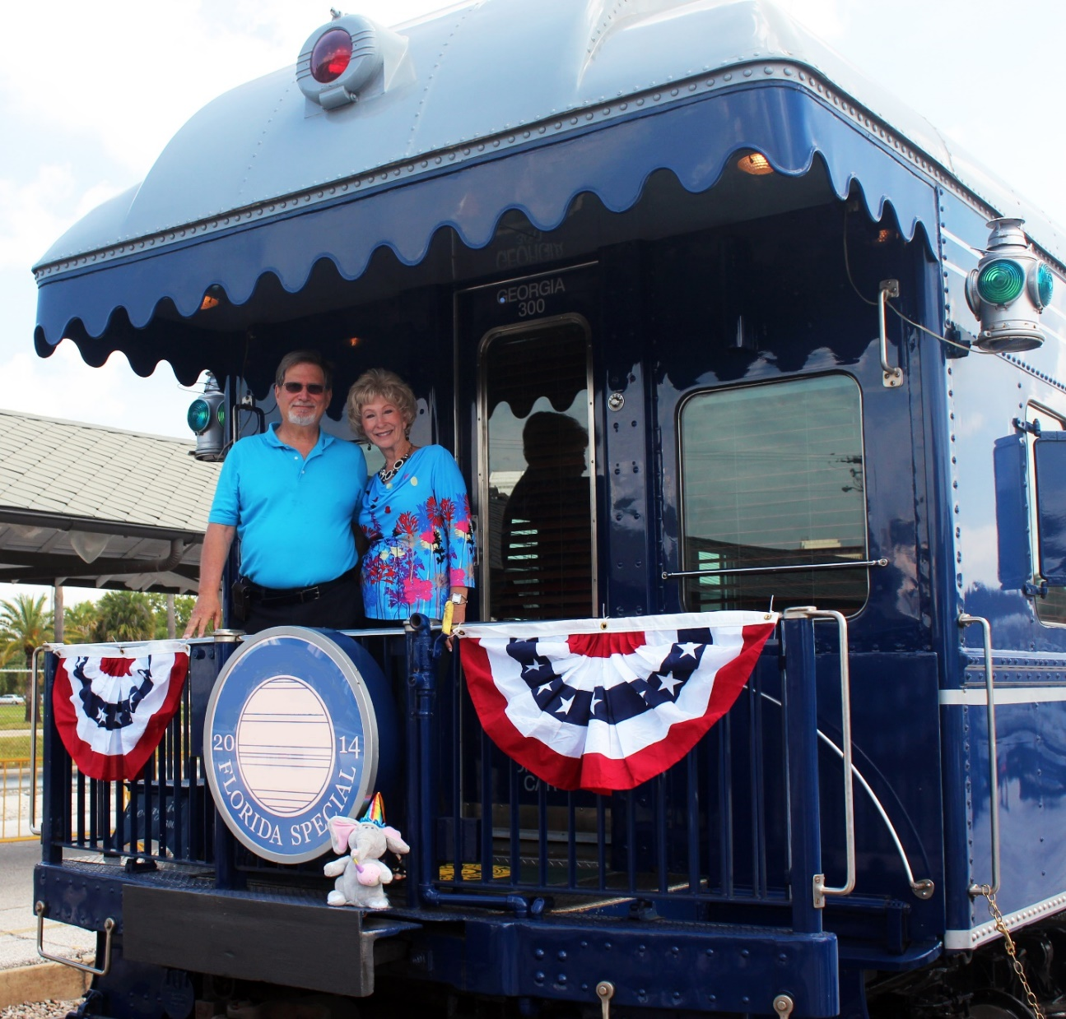

Jeff and Ginny Orenstein at Tampa, Florida Union Station

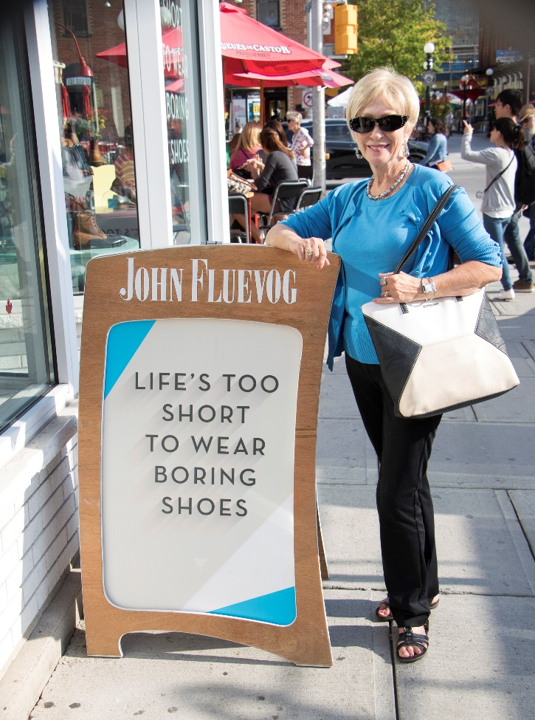  
 Ginny Orenstein in Ottawa, Canada

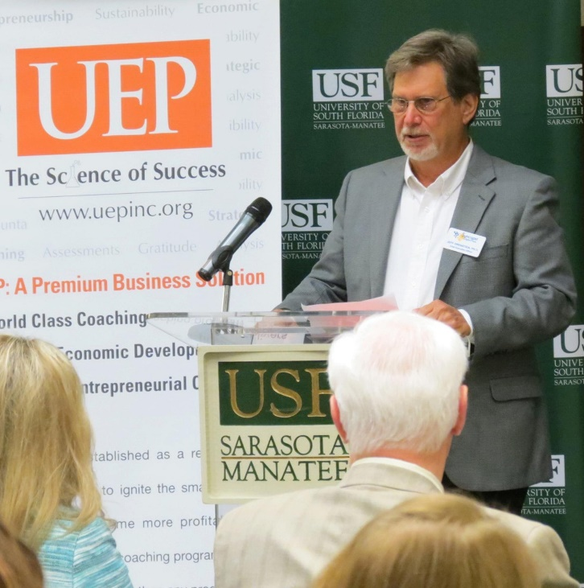

Jeff Orenstein in Sarasota Florida